September | Grade 2/3 Mrs. Ward 832-5800 ext:244, bward2@staff.ednet.ns.ca
Themes: Friendships, Anti-bully Awareness,  School Rules and Routines and Goal Setting  Concepts: Graphing (Tallies, Bar and Pictographs) Number Sense (place value, comparing, writing #’s) Mental Math (Count On/Back, 100 Chart, Doubles) L.A (Connecting to Fiction, Story Elements) Social Studies (Mapping), Science (Water states, absorption and conservation) Health (Friendships, Peer Influence, Bullying, Emotions and Safety) Art (Expressing themselves with Elements of Colour) | 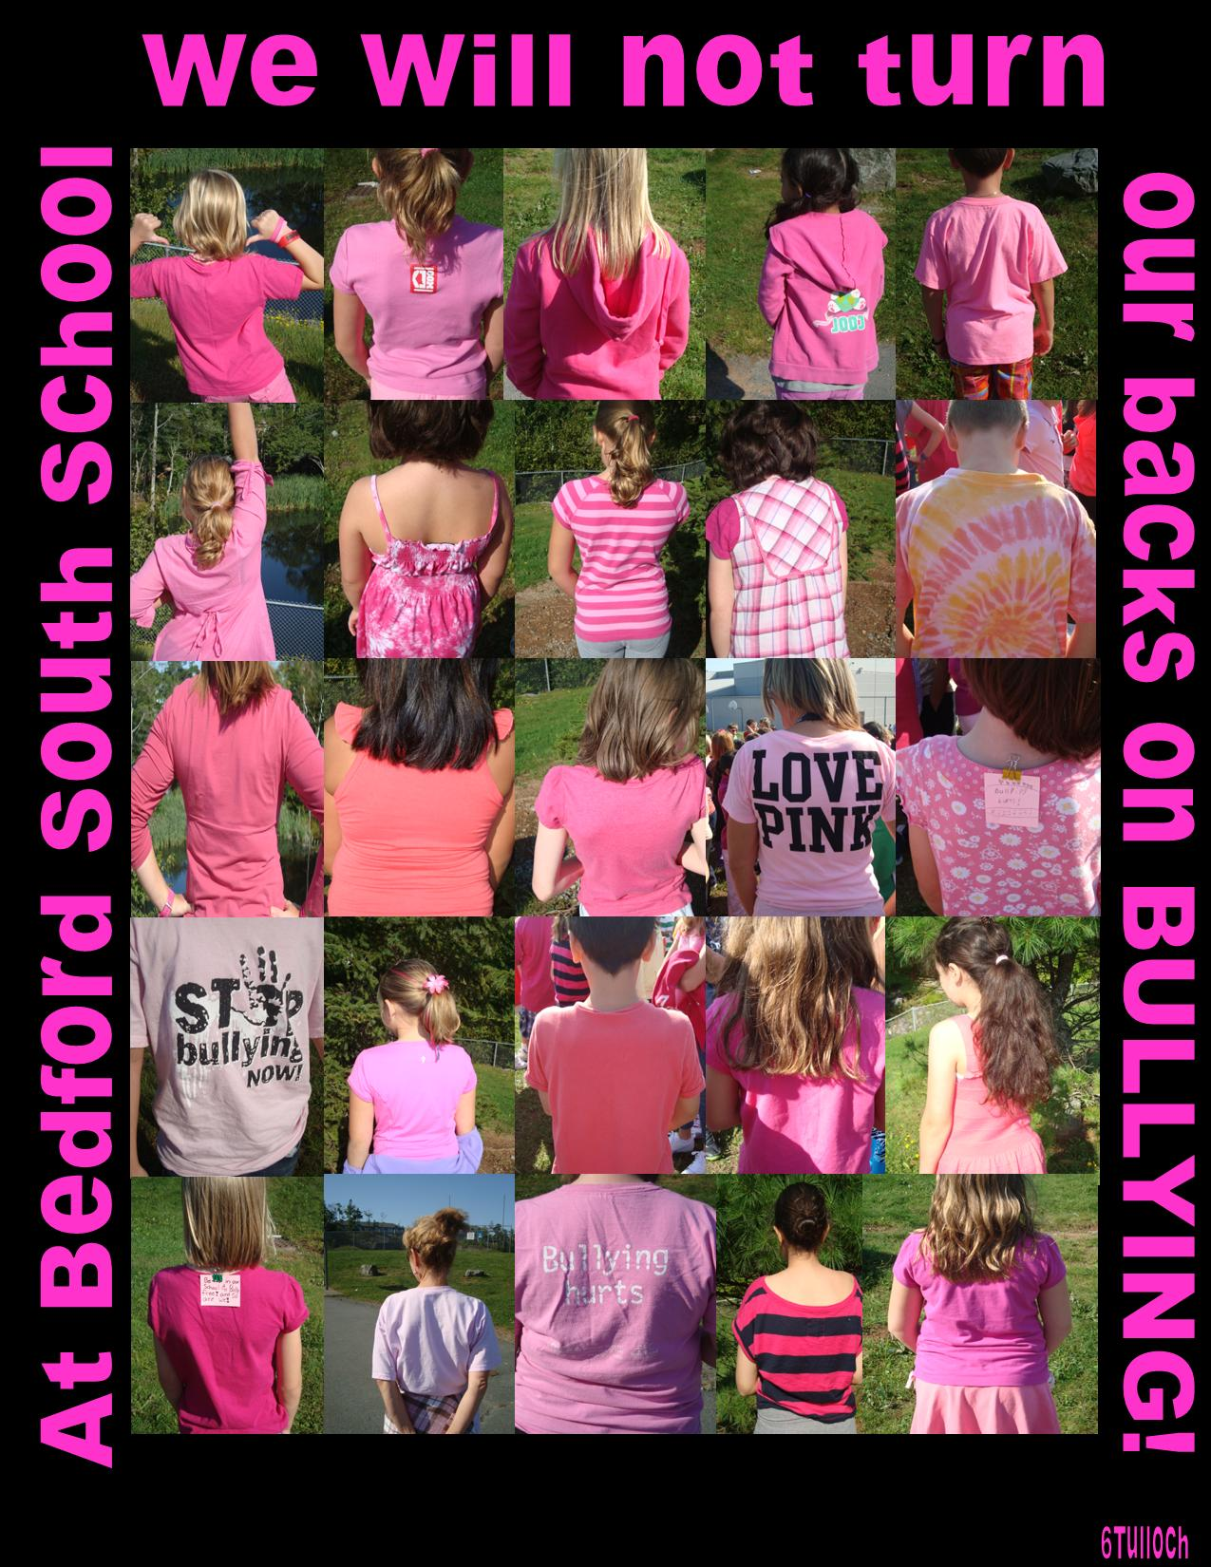
 | Fusce dolor odio, gravida interdum, rutrum gravida, vulputate eget, arcu. In gravida eros vitae orci. Suspendisse tincidunt scelerisque pede.

Sunday | Monday | Tuesday | Wednesday | Thursday | Friday | Saturday
 |  |  |  |  |  | September 1
2 | 3 | 4 | 5 | 6 | 7 | 8
 |  |  | LIBRARY  (Gr.2 go home  at 2:20) | MUSIC | GYM
9 | 10 | 11 | 12 | 13 | 14 | 15
 | MUSIC | GYM | LIBRARY  (Gr.2 go home  at 2:20) | MUSIC | GYM
16 | 17 | 18 | 19 | 20 | 21 | 22
 | MUSIC | GYM | LIBRARY  (Gr.2 go home  at 2:20) | MUSIC  HSA Ice Cream Social 6:30-8:30 pm | GYM | First Day of Fall
23 | 24 | 25 | 26 | 27 | 28 | 29
 | MUSIC  Star Student: Tia | GYM | LIBRARY  (Gr.2 go home  at 2:20)  Yom Kipper | MUSIC  Curriculum night - 6:00  Terry Fox Run | PD Day - no school for students | Bluenose Launch in Luneburg, NS
30 | October 1
 | Star Student: Natalie | Oct. 3 & 4th School photos  Oct. 8 Thanksgiving Day

